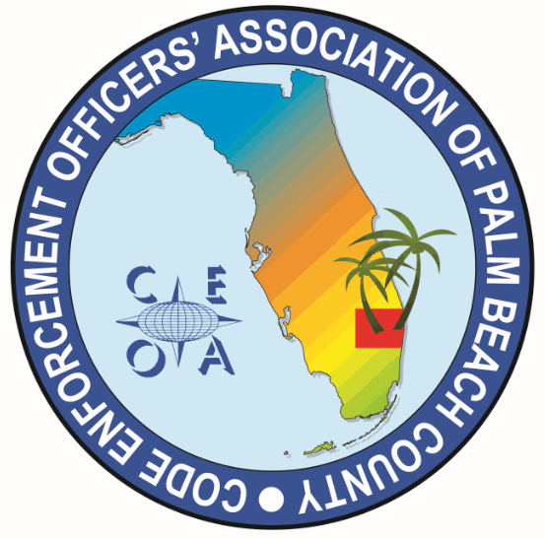

CODE ENFORCEMENT OFFICERS ASSOCIATION OF PALM BEACH COUNTY
BOARD MEETING AGENDA
NOVEMBER 12, 2025
11:30 AM
EATALIA
7750 OKEECHOBEE BLVD WEST PALM BEACH, FL 33411

CALL MEETING TO ORDER, ROLL CALL, ESTABLISH A QOURUM, RULES OF MEETING

APPROVAL OF THE JULY 8, 2025, MEETING MINUTES – MICHELLE MALKIN DANIELS

TRASURER REPORT – JOE OLIVA

OLD BUSINESS

- BYLAW REVIEW COMMITTEE UPDATE – DWAYNE JOHNSON

- CEOAPBC MEMBERSHIP DUES $27 DUE OCTOBER 1ST AND ARE DELIQUENT DECEMBER 1ST
- Review membership list, contact jurisdictions who are not members (Rivera Beach, Tequesta, Ocean Ridge Manalapan ect.)

NEW BUSINESS
- FUTURE TRAINING SPEAKERS AND LOCATIONS – SONJA BINS
- Report Writing for Code officials 6 CEUs at the City of Delray Beach Library *Announcement to be sent out today directly after meeting*

- DISCUSION ON HOLIDAY LUNCH DURING THE TRAINING BLOCK

- ITEMS TO BE CONSIDERED FOR NEXT MEETING AGENDA

- SET NEXT MEETING DATE AND TIME *Elections and Annual meeting in March 2026

ADJOURNMENT

